

health, relationships and sex education policy
Written by Julia Kinch (Headteacher) in consultation with key stakeholders – February 2020.

  - REVIEW: JULY 24
st philip’s ce Primary School

Rationale and Ethos
This policy covers our approach to the teaching of relationships and sex education (RSE) at our school. It has been written by the senior leadership team in consultation with Governors, parents/carers and pupils.
We define ‘relationships and sex education’ as the development of pupils’ emotional, social and cultural understanding. This includes learning about family relationships, caring friendships, respectful relationships (including in the online world), staying safe and understanding about healthy lifestyles and its impact on wellbeing.

Roles and Responsibilities

The governing board
The governing board will approve the RSE policy, and hold the headteacher to account for its implementation.

The headteacher
The headteacher is responsible for ensuring that RSE is taught consistently across the school, and for managing requests to withdraw pupils from non-statutory components of RSE (See page 2: Parents’ Right to Withdraw).

Staff
Staff are responsible for:
- Delivering RSE in a sensitive way
- Modelling positive attitudes to RSE
- Monitoring progress
- Responding to the needs of individual pupils
- Responding appropriately to pupils whose parents wish them to be withdrawn from the non-statutory components of RSE
- Respond professionally to questions raised by pupils during PSHE/RSE lessons
Staff do not have the right to opt out of teaching RSE. Staff who have concerns about teaching RSE are encouraged to discuss this with the headteacher.
All PSHE/RSE lessons will be delivered by a member of teaching staff at St Philip’s CE Primary School.
Staff are trained on the delivery of RSE as part of continuing professional development linked to staff meetings and INSET days; this may include visitors from external agencies to provide support and additional training.

Pupils
Pupils are expected to engage fully in RSE and, when discussing issues related to RSE, treat others with respect and sensitivity.

Legislation (statutory legislations and regulations)
As a maintained primary school we must provide relationships education to all pupils as per section 34 of the Children and Social work act 2017.
However, we are not required to provide sex education but we do need to teach the elements of sex education contained in the science curriculum.
In teaching RSE, we must have regard to guidance issued by the secretary of state as outlined in section 403 of the Education Act 1996.
As of September 2020, all primary schools must deliver relationships education (as set out in the revised statutory guidance from the DfE).
At St Philip’s CE Primary School we teach RSE as set out in this policy.

Parents’ right to withdraw
Parents do not have the right to withdraw their children from relationships education.
Parents have the right to withdraw their children from the non-statutory components of sex education within RSE.
Requests for withdrawal should be put in writing using the form in Appendix 3 and addressed to the headteacher.
Alternative work will be given to pupils who are withdrawn from sex education.

Curriculum Design
Our curriculum is set out alongside our PSHE curriculum – as identified in Appendix 1 but this may need to be adapted as and when necessary.
The curriculum has been developed and reviewed in consultation with all stakeholders (parents/carers, pupils and staff) taking into account the age, needs and feelings of pupils. If pupils ask questions outside the scope of this policy, teachers will respond in an appropriate manner so they are fully informed and don’t seek answers online.
RSE is taught within the personal, social, health and economic (PSHE) education curriculum. Biological aspects of the RSE are taught within the science curriculum and other aspects are included in other areas of the curriculum, including religious education (RE).
Pupils also receive stand-alone sex education sessions delivered by trusted professionals and may be supported by a trained health professional.
Primary sex education will focus on:
- Preparing boys and girls for the changes that adolescence brings
- How a baby is conceived and born
Relationships education focuses on teaching the fundamental building blocks and characteristics of positive relationships including:
- Families and People Who Care for Me
- Caring Friendships
- Respectful Relationships
- Online relationships
- Being Safe
Health education focuses on teaching the fundamental building blocks and characteristics of positive attitudes to physical health and mental wellbeing:
- Mental Wellbeing
- Internet Safety and Harms
- Physical Health and Fitness
- Healthy Eating
- Drugs, Alcohol and Tobacco
- Health and Prevention
- Basic First Aid
- Changing Adolescent Body
The curriculum has been designed to be delivered using a range of sources and materials (PIXL Edge and Mind to Be Kind, Framework for a Connected World), external input (e.g., NSPCC) and additional experiences, including specifically timetabled weeks (Mental Health Week and Healthy Living Week). School is also affiliated to Stonewall.
Sex and relationships education is delivered through the use of key resources in Upper Key Stage 2 using “Real Love Rocks” and “Growing Up…Growing Wise” (following a Christian viewpoint).
All aspects of learning are taught within the context of family life and reflecting on the Christian foundation of our school, taking care to ensure that there is no stigmatisation of children based on their home circumstances. Children are taught to recognise that families can include single parent families, LGBT parents/carers, families headed by grandparents, adoptive parents, foster parents/carers, and children cared for by family members amongst other structures. Children are taught to reflect on alternative support networks including those for Young Carers and Looked After Children.
For additional information about our curriculum, see the overview in Appendix 1.
The expectations for the end of Primary School is detailed in Appendix 2.

Safe and Effective Practice
At St Philip’s CE we ensure a safe learning environment where children are encouraged to share their ideas and thoughts through clearly agreed ground rules and boundaries. In the context of relationships education, children may share their questions confidentially and anonymously through the use of post-it notes and the class worry monsters.
Questions will be answered in the context of planned sessions and any sensitive issues will be considered within the context of the cohort. All staff teaching RSE will be supported to address key questions through training and additional support from the safeguarding team.
Sensitive issues may be addressed individually and in consultation with parents as required and assessed by the staff and pastoral team.

Safeguarding
Staff at St Philip’s are aware that effective RSE teaching, which brings an understanding of what is and what is not an appropriate in a relationship, can lead to a disclosure of a child protection issue. As such, all staff at St Philip’s will consult with the designated safeguarding lead (Julia Kinch – Headteacher) and/or their deputy (Paul Steaman – CFDO, Vannessa Taylor – Phase 1 Lead; Jayne Smedley – Learning Mentor) in their absence. The appropriate safeguarding processes will be adhered to should this arise.
Visitors/External agencies supporting the delivery of RSE will be required to adhere to all school safeguarding processes and will be supported in session delivery by appropriately trained staff to ensure that protocols are maintained.

Engaging Stakeholders
Parents/Carers will be informed about this policy through consultation meetings and individual meetings with the Headteacher as required.
The policy will be available to the parents through the school website and on request at the school office.
We are committed to working closely with Parents/Carers to ensure that they are fully aware of the nature of the RSE curriculum and what is being taught. Through the delivery of additional meetings and workshops, Parents/Carers are given the opportunity to review resources and ask additional questions or raise concerns. Individual meetings will also be offered to Parents/Carers with additional concerns.
We will notify Parents/Carers about the delivery of Sex Education through a separate letter and additional parent meeting to review the resources and answer questions. Please see the section relating to the Right to Withdraw on Page 2 of this policy.
Governors will be informed of the SRE policy through the Governing Board Meetings and through the sharing of information in Link Governor Meetings or Governor Fact Find Activities.
Pupil voice is reflected in the curriculum through the questions that are asked and through the curriculum development questions asked in school council meetings. These may be reflected in changes made to the way that lessons may be delivered.

Monitoring, Reporting and Evaluation
Staff will reflect on their teaching through the outcomes reflected in pupil work, including pupil discussion. Staff may request additional support to address key issues which may come from external agencies but also from experienced staff in the school team, including the Mental Health First Aiders.
Children will be given the opportunity to reflect on their learning through structured class discussion, drama activities, recording in books and in shared class work (although this list is not exhaustive). The responses children make to their learning will inform future learning and ensure that staff address concerns raised and/or miscconceptions.

Policy Review Date

Review Date: September 2021
Policy Reviewer: Julia Kinch (Headteacher)

appendix 1 – curriculum overview

Topic Overview and Resources used
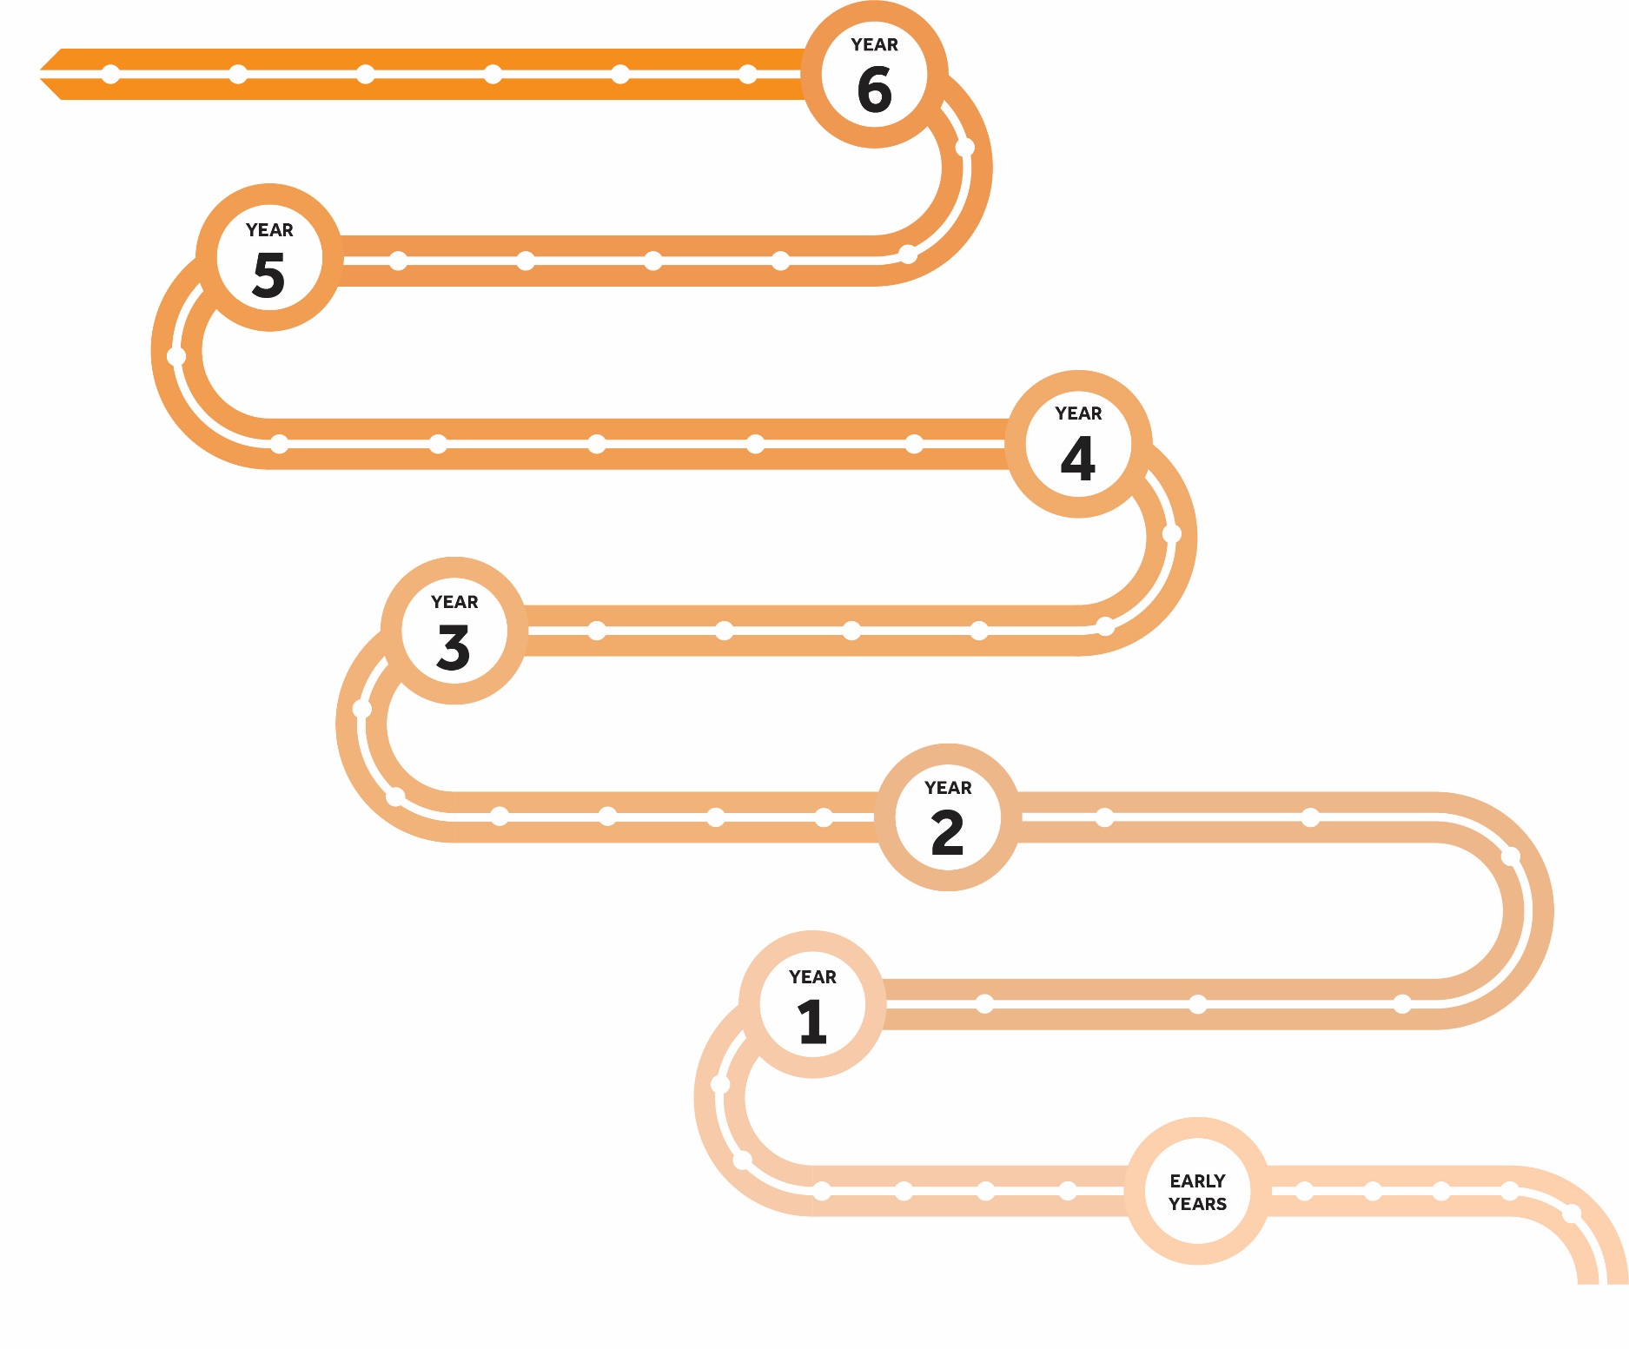
Transition
Term 1
Confident Changes
Term 2
Getting there
Term 1
Making plans
Term 2
Exploring what’s around me
Term 3
Stepping up
Term 3
Discovering
my voice
Term 1
Building my confidence
Term 2
Interacting with others
Term 3
Using my voice
Term 1
What makes me?
Term 2
Where I fit in
Term 3
Planning to succeed
Term 1
Charting my journey
Term 2
Overcoming obstacles
Term 3
Equipping for the next journey
Term 2
Settling in
Term 3
Stepping forward
Term 1
Am I ready?
Term 3
Sex Education
Term 3
Sex Education
Mind To Be Kind
Foundation

- Leadership
- Organisation
- Resilience
- Initiative
- Communication
LORIC Lessons – PIXL

Wellbeing - PIXL
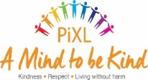
Real Love Rocks - SRE
Mind to be Kind

Growing Up, Growing Wise - SRE
Digital Citizenship - E-Safety
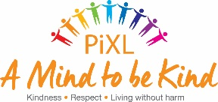
Evolve – E-Safety
Visitors – NSPCC, School Nurse, Road Safety, Freddie Fit
appendix 2 – end of primary school expectations

Relationships Education
Topic | Pupils should know
Families and people who care about me | - That families are important for children growing up because they can give love, security and stability  - The characteristics of healthy family life, commitment to each other, including in times of difficulty, protection and care for children and other family members, the importance of spending time together and sharing each other’s lives  - That others’ families, either in school or in the wider world, sometimes look different from their family, but that they should respect those differences and know that other children’s families are also characterised by love and care  - That stable, caring relationships, which may be of different types, are at the heart of happy families, and are important for children’s security as they grow up  - That marriage represents a formal and legally recognised commitment of two people to each other which is intended to be lifelong  - How to recognise if family relationships are making them feel unhappy or unsafe, and how to seek help or advice from others if needed
Caring friendships | - How important friendships are in making us feel happy and secure, and how people choose and make friends  - The characteristics of friendships, including mutual respect, truthfulness, trustworthiness, loyalty, kindness, generosity, trust, sharing interests and experiences and support with problems and difficulties  - That healthy friendships are positive and welcoming towards others, and do not make others feel lonely or excluded  - That most friendships have ups and downs, and that these can often be worked through so that the friendship is repaired or even strengthened, and that resorting to violence is never right  - How to recognise who to trust and who not to trust, how to judge when a friendship is making them feel unhappy or uncomfortable, managing conflict, how to manage these situations and how to seek help or advice from others, if needed
Respectful relationships | - The importance of respecting others, even when they are very different from them (for example, physically, in character, personality or backgrounds), or make different choices or have different preferences or beliefs  - Practical steps they can take in a range of different contexts to improve or support respectful relationships  - The conventions of courtesy and manners  - The importance of self-respect and how this links to their own happiness  - That in school and in wider society they can expect to be treated with respect by others, and that in turn they should show due respect to others, including those in positions of authority  - About different types of bullying (including cyberbullying), the impact of bullying, responsibilities of bystanders (primarily reporting bullying to an adult) and how to get help  - What a stereotype is, and how stereotypes can be unfair, negative or destructive  - The importance of permission-seeking and giving in relationships with friends, peers and adults
Online relationships | - That people sometimes behave differently online, including by pretending to be someone they are not  - That the same principles apply to online relationships as to face-to face relationships, including the importance of respect for others online including when we are anonymous  - The rules and principles for keeping safe online, how to recognise risks, harmful content and contact, and how to report them  - How to critically consider their online friendships and sources of information including awareness of the risks associated with people they have never met  - How information and data is shared and used online
Being safe | - What sorts of boundaries are appropriate in friendships with peers and others (including in a digital context)  - About the concept of privacy and the implications of it for both children and adults; including that it is not always right to keep secrets if they relate to being safe  - That each person’s body belongs to them, and the differences between appropriate and inappropriate or unsafe physical, and other, contact  - How to respond safely and appropriately to adults they may encounter (in all contexts, including online) whom they do not know  - How to recognise and report feelings of being unsafe or feeling bad about any adult  - How to ask for advice or help for themselves or others, and to keep trying until they are heard  - How to report concerns or abuse, and the vocabulary and confidence needed to do so  - Where to get advice e.g. family, school and/or other sources

Physical Health and Wellbeing
Topic | Pupils should know
Mental Wellbeing | - That mental wellbeing is a normal part of daily life, in the same way as physical health.  - That there is a normal range of emotions (e.g., happiness, sadness, anger, fear, surprise, nervousness) and scale of emotions that all humans experience in relation to different experiences and situations.  - How to recognise and talk about their emotions, including having a varied vocabulary of words to use when talking about their own and others’ feelings.  - How to judge whether what they are feeling and how they are behaving is appropriate and proportionate.  - The benefits of physical exercise, time outdoors, community participation, voluntary and service-based activity on mental wellbeing and happiness.  - Simple self-care techniques, including the importance of rest, time spent with friends and family and the benefits of hobbies and interests.  - Isolation and loneliness can affect children and that it is very important for children to discuss their feelings with an adult and seek support.  - That bullying (including cyberbullying) has a negative and often lasting impact on mental wellbeing.  - Where and how to seek support (including recognising the triggers for seeking support), including whom in school they should speak to if they are worried about their own or someone else’s mental wellbeing or ability to control their emotions (including issues arising online).  - It is common for people to experience mental ill health. For many people who do, the problems can be resolved if the right support is made available, especially if accessed early enough.
Internet Safety and Harms | - That for most people the internet is an integral part of life and has many benefits.  - About the benefits of rationing time spent online, the risks of excessive time spent on electronic devices and the impact of positive and negative content online on their own and others’ mental and physical wellbeing.  - How to consider the effect of their online actions on others and know how to recognise and display respectful behaviour online and the importance of keeping personal information private.  - Why social media, some computer games and online gaming, for example, are age restricted.  - That the internet can also be a negative place where online abuse, trolling, bullying and harassment can take place, which can have a negative impact on mental health.  - How to be a discerning consumer of information online including understanding that information, including that from search engines, is ranked, selected and targeted.  - Where and how to report concerns and get support with issues online.
Physical Health and Fitness | - The characteristics and mental and physical benefits of an active lifestyle.  - The importance of building regular exercise into daily and weekly routines and how to achieve this; for example walking or cycling to school, a daily active mile or other forms of regular, vigorous exercise.  - The risks associated with an inactive lifestyle (including obesity).  - How and when to seek support including which adults to speak to in school if they are worried about their health.
Healthy Eating | - What constitutes a healthy diet (including understanding calories and other nutritional content).  - The principles of planning and preparing a range of healthy meals.  - The characteristics of a poor diet and risks associated with unhealthy eating (including, for example, obesity and tooth decay) and other behaviours (e.g. the impact of alcohol on diet or health).
Drugs, Alcohol and Tobacco | - The facts about legal and illegal harmful substances and associated risks, including smoking, alcohol use and drug-taking.
Health and Prevention | - How to recognise early signs of physical illness, such as weight loss, or unexplained changes to the body.  - About safe and unsafe exposure to the sun, and how to reduce the risk of sun damage, including skin cancer.  - The importance of sufficient good quality sleep for good health and that a lack of sleep can affect weight, mood and ability to learn.  - About dental health and the benefits of good oral hygiene and dental flossing, including regular check-ups at the dentist.  - About personal hygiene and germs including bacteria, viruses, how they are spread and treated, and the importance of handwashing.  - The facts and science relating to allergies, immunisation and vaccination.
Basic First Aid | - How to make a clear and efficient call to emergency services if necessary.  - Concepts of basic first-aid, for example dealing with common injuries, including head injuries.
Changing Adolescent Body | - Key facts about puberty and the changing adolescent body, particularly from age 9 through to age 11, including physical and emotional changes.  - About menstrual wellbeing including the key facts about the menstrual cycle.

appendix 3 – right to withdraw form

To be completed by parents
Name of child |  | Class
Name of parent |  | Date
Reason for withdrawing from sex education within relationships and sex education
Any other information you would like the school to consider
Parent signature

To be completed by the school
Agreed actions from discussion with parents

