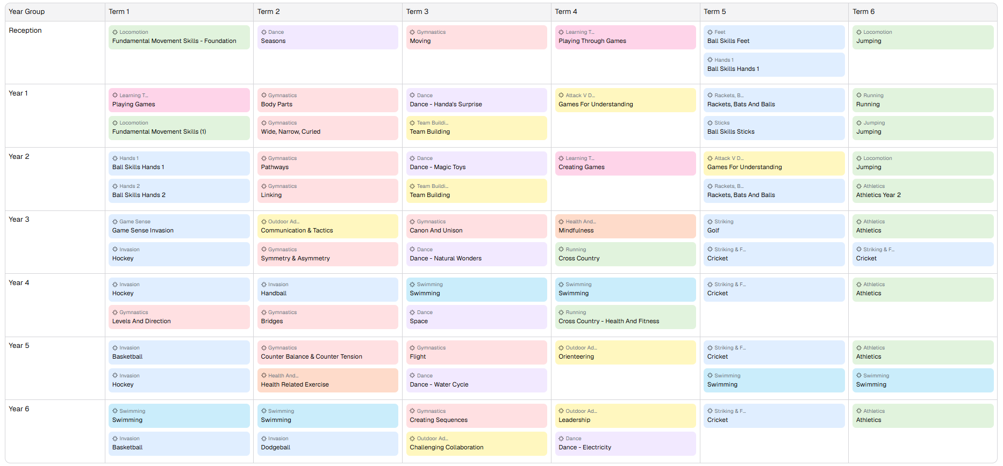
Competitions
- 3v3 Basketball Cricket
- Dodgeball Football
- Hockey Athletics
- Handball Graystones Action Sports
- Cross Country Triathlon
- Swimming Fencing

